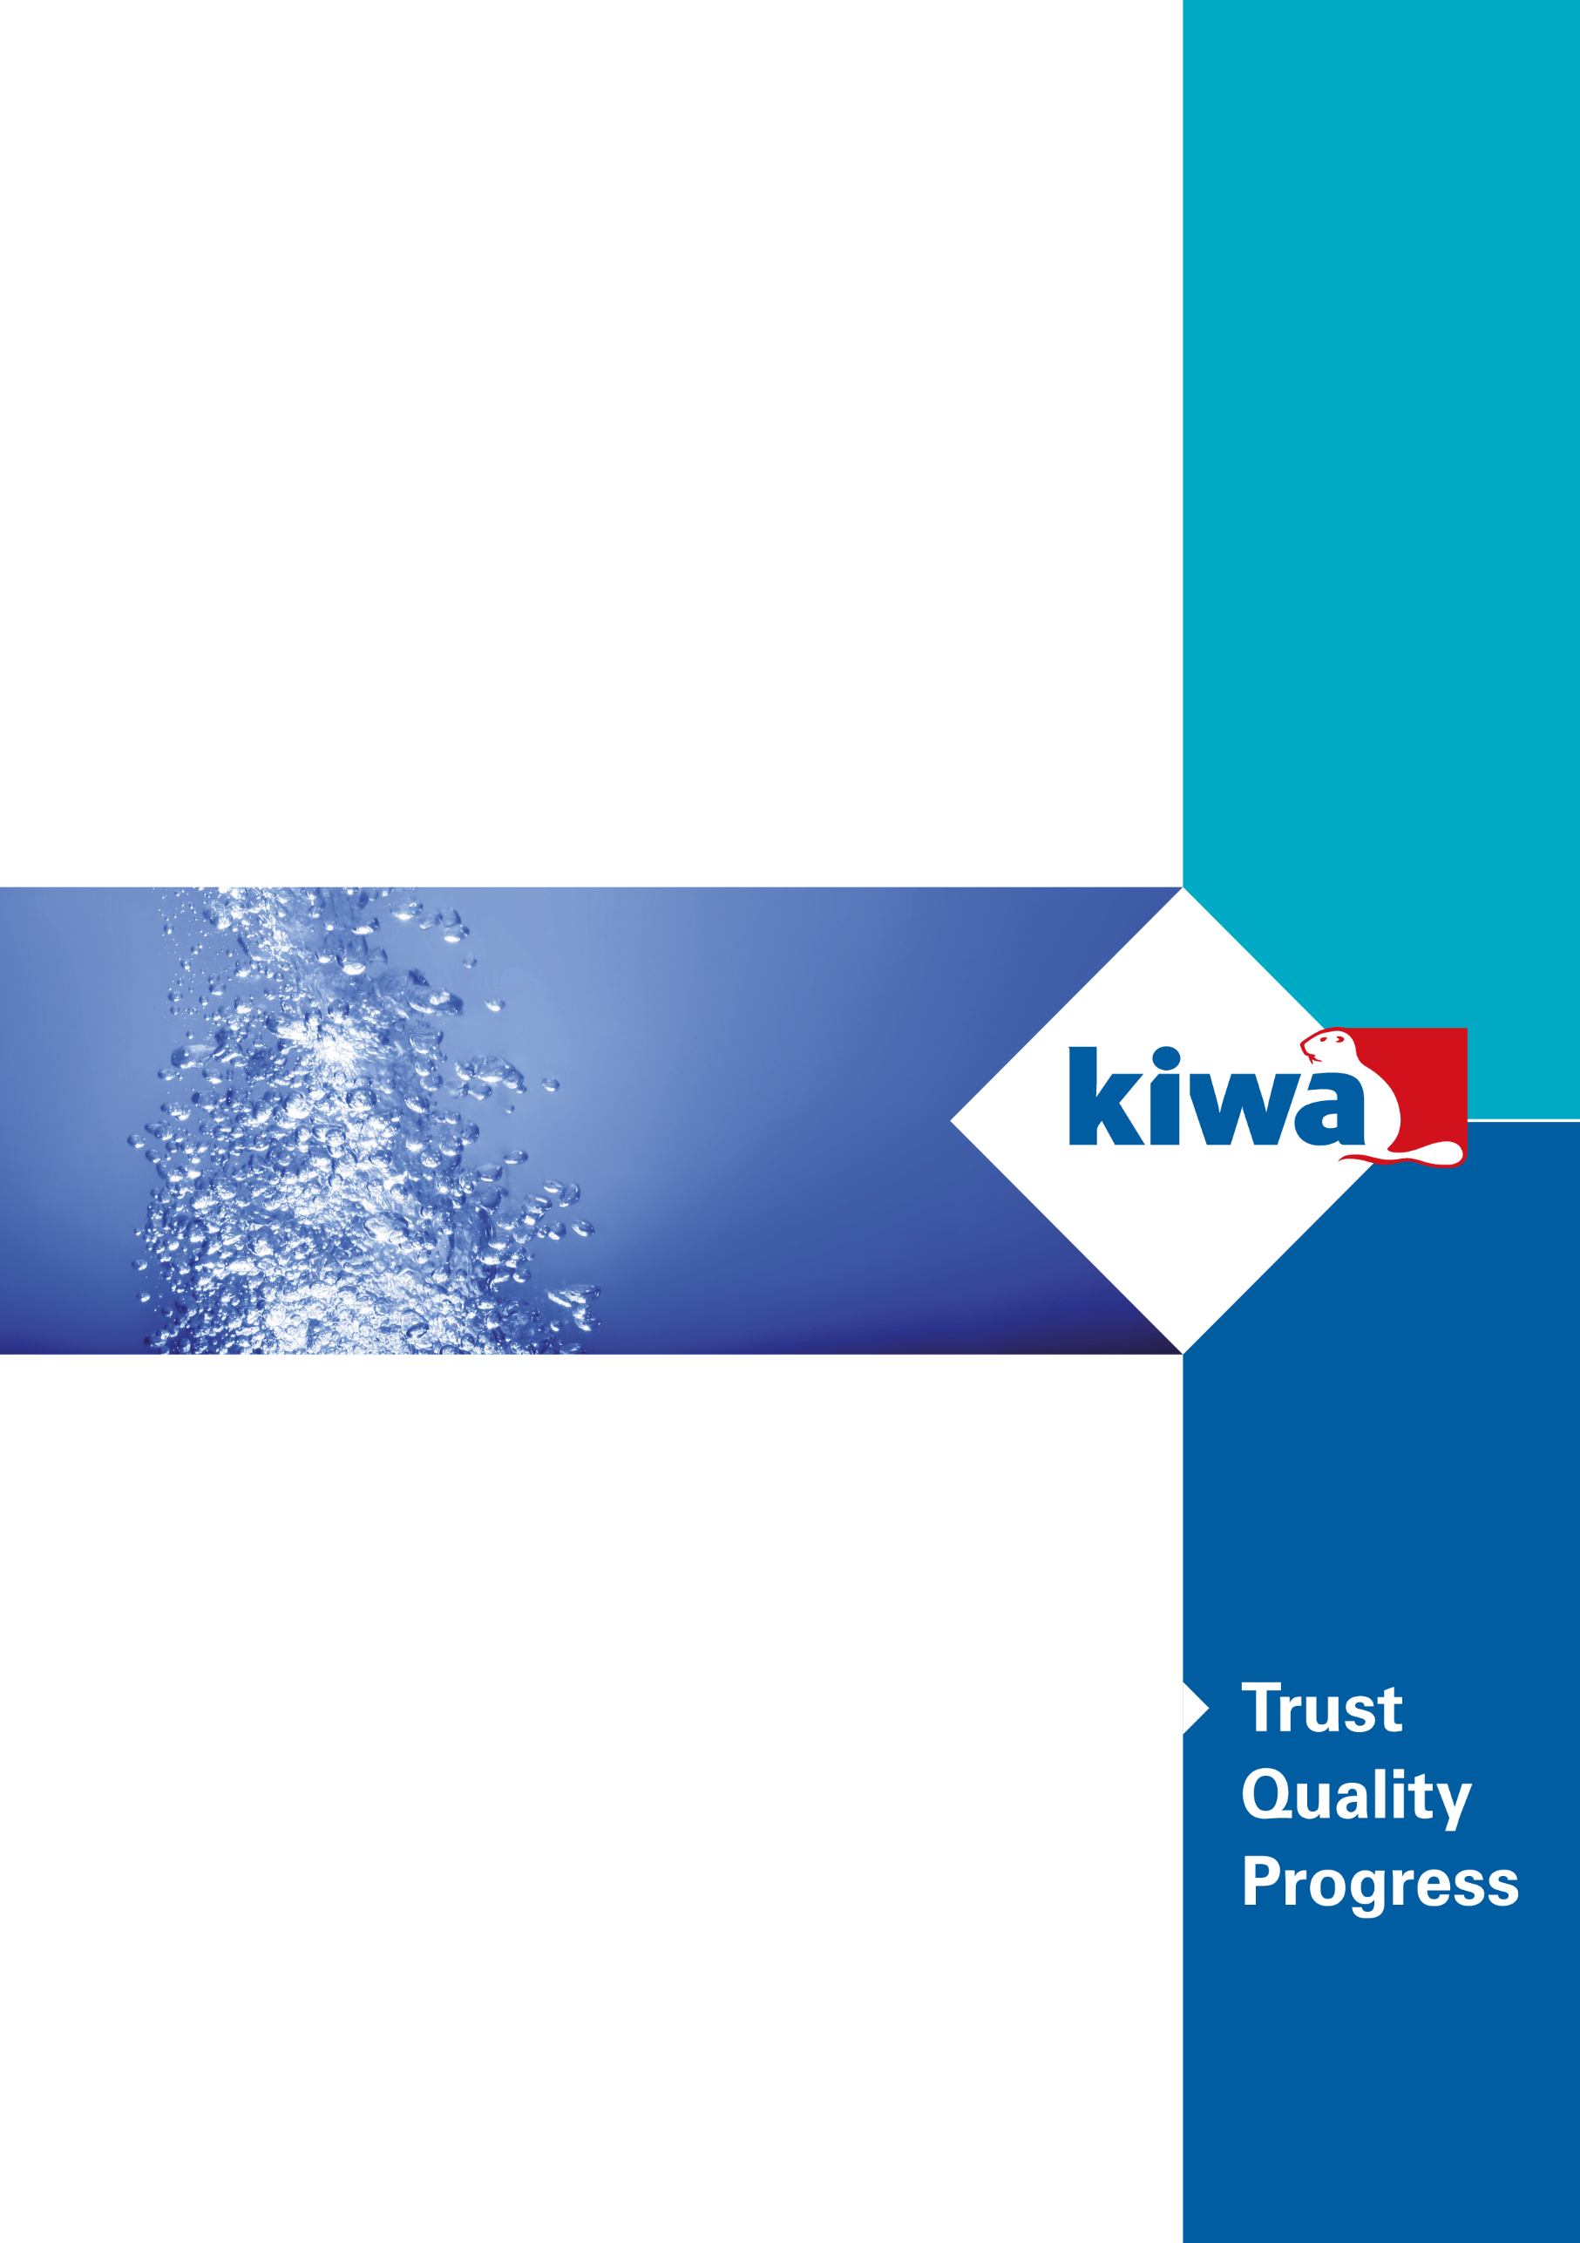
Evaluation Guideline
for the Kiwa Watertec certificate for
- Regulation 4(1)(a) Compliance – UK Water Regulations.
- Attestation Level 1+ or 3
Kiwa Watertec - EG004
Issue No 6 – 21.05.2024

Preface
This evaluation guideline has been accepted by the Kiwa Watertec Expert Group, in which parties concerned in the Drinking Water sector in the UK are being represented. This Kiwa Watertec Expert Group also supervises the certification activities and where necessary requires this guideline to be revised.

This evaluation guideline will be used by Kiwa Watertec in conjunction with the Kiwa-Regulations for Product Certification. This guidline details the methods employed by Kiwa for conducting the necessary investigations prior to issuing the product certificate and the method of external control.
The Kiwa-Regulations for Product Certification also refer to the “Kiwa Regulations for the Board of Appeal”. In reference to what has been mentioned in clause 2.1 of these regulations, the chairman and deputy chairman do not need to have a university degree in law.

This evaluation guideline is to be assessed by the Kiwa Watertec Expert Group at least every 5 years, but at the latest before May 2029.

1 Introduction 5
1.1 General 5
1.2 Field of application / scope – UK Water Regulations & Byelaws as relevant 5
1.3 Acceptance of test report(s) provided by the supplier 5
1.4 Acceptance of products that have an existing certification 5
1.5 KUKreg4 certificate 6
2 Terms and definitions 7
3 Process for gaining Certification 8
3.1 Certification process 8
3.2 Pre & post certification evaluation & initial audit/inspection 8
3.3 Granting of the certificate 8
3.4 Additions and modifications to an existing certificate 8
4 Requirements and test methods 10
4.1 General 10
4.2 Product requirements and test methods 10
4.3 Materials in contact with water 10
4.4 Appropriate standards 10
4.5 Additional specifications/tests 11
4.6 Materials in contact with water 11
4.7 Opptional additional testing 11
5 Sampling 12
5.1 General 12
5.2 Sampling requirments 12
5.3 Re-test/failure 12
5.4 Products which are already Kiwa certified products 12
6 Installation and Maintenance documents 13
7 Marking 14
7.1 General 14
8 Requirements in respect of the quality system 15
8.1 General 15
8.2 Internal quality control/quality matrix 15
8.3 Procedures and working instructions 15
9 Summary of tests and audit/inspections 1+ 16
9.1 General 16
9.2 Test & audit/inspection Matrix Level 1+ 16
10 Agreements on the implementation of certification 17
10.1 General 17
10.2 Certification staff 17
10.3 Report initial invetigation 17
10.4 Decision for granting the certificate 17
10.5 Lay out of certification certificate 17
10.6 Nature and frequency of third party audits/inspections 17
10.7 Interpretation of requirements 18
10.8 Access for site audit/inspection (if required) 18
10.9 Co-operation with Kiwa 18
10.10 Company records of complaints about its certified products 18
10.11 Modification and or addition to certified product(s) 18
10.12 Secondary certification 18
10.13 Fees 19
10.14 Complaints & appeals 19
10.15 Certification withdrawn 19
Annex A: Model Certificate 20
Annex B: Model IQC-scheme 23

Introduction

General
This evaluation guideline includes all relevant requirements which will be used by Kiwa Watertec as the basis for the issue and maintenance of an EN-ISO –IEC 17065 product certification that verifies compliance with the UK Water Supply (Water Fittings) Regulations/Byelaws – Regulation 4(1)(a) in that: The water fitting is of an appropriate quality and standard.

Kiwa are offering as an option an opportunity to test products against the Unified Water Label (UWL) performance criteria, the KUKreg4 certification can then be used to become a UWL marked product.

KUKreg4 certification includes alternatives for the level of surveillance required, these being:

Level 1+ requiring:
- initial type testing
- initial and annual audit/inspection of the manufacturing plant(s) factory production control (fpc)
- FPC testing as part of the production process
- initial and annual audit/inspection/review of the non-metallic materials in contact with water and compliance with BS 6920

The certification period being indefinite if all the schemes’ requirements are satisfied at the time of the annual audit/inspection.

Level 3 requiring:
- initial type testing
- initial verification of factory production control (ISO 9001 or verification of fpc)
- initial review of the non-metallic materials in contact with water and compliance with BS 6920.

The certification period is 5 years and will require re-type testing etc as detailed above.
Secondary certification holders will be required to have ISO 9001 or their fpc must be verified as being acceptable with their certification period being the same as the primary product.

Field of application / scope – UK Water Regulations & Byelaws as relevant
Water Supply (Water Fittings) Regulations 1999 England & Wales. The Water Supply (Water Fittings) Regulations (Northern Ireland) 2009. The Water Byelaws (Water Fittings) (Scotland) Byelaws 2014

Compliance with the UK Regulators Specifications is applicable for each generic product type. The exact applicable specifications are detailed in the Kiwa test matrix and can be developed for non-standard product(s) and then agreed by certification as and when required. For assembled products, each generic component may require testing if the component is not already verified as being appropriate and complying with Reg 4 of the Water Supply (Water Fittings) Regulations.
Or
Compliance to an appropriate standard which can show compliance to the relevant requirements stated in the Water Supply (Water Fittings) Regulations 1999 and the appropriate additional UK Regulators Specification will be applied where applicable. See clause 4.4.

Acceptance of test report(s) provided by the supplier
When appropriate test reports from an EN-ISO/IEC 17025 accredited laboratory, a Kiwa product certificate or an approval certificate from an EN-ISO/IEC 17065 accredited certifier are supplied to demonstrate that the product meets the requirements of this evaluation guideline.

The laboratory shall be accredited to EN-ISO/IEC 17025 and include within their scope of accreditation the standards or specifications referred in this evaluation guideline.
The certifier shall be accredited to EN-ISO/IEC 17065 and include within their scope of accreditation the standards or specifications referred in this evaluation guideline.

These requirements are considered to have been fulfilled when a test report or certificate of accreditation can be shown, either issued by UKAS or one of the institutions with which UKAS has an agreement of mutual acceptance (ILAC).

Validity of tests reports/certification to be 5 years or as determined by the Kiwa Watertec Expert Group.
Kiwa Watertec will reserve the right to inspect the laboratory/certifier and require inter-laboratory trials and details of the laboratory procedures (in English) for testing and to carry out site-inspections, as necessary.

Acceptance of products that have an existing certification
Applicants who have an existing non Kiwa certification that requires a KUKreg4 certification, must complete and return the form AA1 for each certification required. Kiwa will review and if appropriate issue certification.

KUKreg4 certificate
The certificate to be issued by Kiwa Watertec is described as the Kiwa Watertec product certificate. A model of the certificate to be issued based on this Evaluation Guideline has been included in Annex A.
Certified products will be shown on the Kiwa Watertec website and will detail a brief description of the certified product(s) and details of the certification holder.
Certification will relate solely to the product(s) referred to in the Kiwa Watertec certificate. Statements by certification holders must refer only to the specifically certified product(s) as designated by the unique model reference.

Terms and definitions
For the products referred to in this evaluation guideline the following terms and definitions are applicable:

Board of Experts (expert group): A board set up by Kiwa Watertec, in which interested parties in the UK Drinking Water sector having a major interest in the development of policies and principles regarding the content and functioning of a certification system may participate and are represented”.
Certificate holder: the entity that enters the Kiwa UK certification agreement.
Evaluation Guideline: details the process and requirements for certification and is agreed by the Board of Experts.
Initial audit/inspection: initial audit of the manufacturing facility/site verifying their Internal quality control; (IQC) system. This is for attestation level 1+ only.
Inspection/audit matrix: details the initial and on-going expectations required to be undertaken to maintain certification.
IQC scheme: (Internal Quality Control): A description of the minimum expectations of the inspections required to be carried out by the supplier(manufacturer). For attestation Level 1+ only.
Pre-certification inspection: an assessment including fpc testing as part of production, materials are acceptable, and that the quality system is adequate to ascertain that all the requirements detailed in the Evaluation Guidelines are satisfied.
Primary certification: applicant who gains the initial certification of the product.
Product certificate: a document, in which Kiwa declares that a product may, on delivery, be deemed to comply with the product specification recorded in the product certificate.
Regulators Specifications’: series of test criteria applied to water products that can be used to determine that a water using product is compliant with the Water Supply (Water Fittings) Regulations/Byelaws.
Secondary certification (private label): applicant who does not manufacture product but uses already certified KUKreg4 product(s).
Supplier (manufacturer) the party that is responsible for ensuring that the product(s) meet and continues to meet the requirements on which the certification is issued.
Surveillance audit/Inspection: on-going audit of the manufacturing facility/site (level 1+ only) carried out after the certification has been issued. Verification that the fpc system and systems in place for the certified product(s) continues to satisfy the requirements recorded in the audit/inspection plan within the certification cycle.
Third Party certification: applies for a primary certification who does not manufacture the product and the manufacture does not have KUKreg4 certification.
Water Fittings: Includes pipes, taps, ferrules, valves, cisterns, mixing valves and similar apparatus used in connection with the supply of water within a building.
Water Regulations are defined in the following:

UK Regulators Specifications | A set of test criteria issued by the UK Government for compliance with the UK Water Supply (Water Fittings) Regulations 1999.
UK Water Supply (Water Fittings) Regulations 1999. | UK Government Regulations protecting the supply of wholesome water supplied by the Water Undertaker
The Water Byelaws (Water Fittings) (Scotland) Byelaws 2014 | Scotland Government Regulations protecting the supply of wholesome water supplied by the Water Undertaker
The Water Supply (Water Fittings) Regulations (Northern Ireland) 2009 | Northern Ireland Government Regulations protecting the supply of wholesome water supplied by the Water Undertaker

Wholesome water. Water supplied by a water undertaker and complying with the requirements of regulations made under section 67 of the Water Industry act 1991. Wholesome water complies with the Drinking Water Directive and is intended for drinking, cooking, food preparation or other domestic purposes (also referred to as Potable Water or drinking water).

Process for gaining Certification

Certification process
- Applicants must complete and return the KUKreg4 application form A1 or equivalent, or if supporting evidence is being provided from other test laboratories then form AA1 must be completed
- The application will be managed by a Project Manager (PM) who will either request further information or will process the application and documentation supplied
- A sample number is assigned for each application made (Calon is used to manage the certification)
- A quote and certification agreement are produced that details the cost for certification and the generic product group to be certified. The certification agreement also refers to the activities related to obtaining and maintaining the Kiwa Watertec Certification for the product(s) detailed in the application document
- The certification agreement must be signed by the applicant and the manufacture of the product (if different) and if the product is not already certified by the manufacture
- The signed certification agreement and any information requested is returned to the PM
- Outstanding queries are resolved between the applicant and the PM and a final contract review of the application is undertaken including review of the non-metallic materials used.
- Test samples are requested (SR1) or test reports are evaluated
- Samples received and then tested
- For level 1+, the on-site audit/inspection of the manufacturing premises is arranged and undertaken, see clause 8.
- For level 3, the fpc is evaluated by either providing the applicants ISO 9001 certificate or details of their quality system, see clause 8
- If the evaluations are satisfactorily completed, then the certification file is collated with the following.
- Test results after evaluation
- Initial inspection of the manufacture/supplier (1+ only)
- ISO9001 or fpc
- Non-Metallic materials are compliant with BS 6920
- Supporting evidence is available (drawings, application fpc etc)
- Certification file is reviewed.
- The certification decision is made as detailed in ISO/IEC 17065 (clause 7.6)
- The Kiwa website is updated (Calon is used to manage the website)
- The product certification certificate is produced and sent to the applicant (Calon)
- For 1+ certification the audit/inspection matrix is developed

Pre & post certification evaluation & initial audit/inspection
The pre & post certification evaluation and testing to be undertaken is based on the generic product requirements that are detailed in this evaluation guideline and include:
- type testing (mechanical).
- verification of the suitability of materials in contact with drinking water to determine whether the product(s) comply with the requirements of the scheme.
- initial audit/inspection of the manufacturing facilities for 1+ Note: this is not required if already a Kiwa Certified Company and the production facility is already inspected annually.
- Assessment of the fpc for level 3.

Granting of the certificate
After completing the post certification evaluation, the results are collated and presented to the decision-maker for consideration. This person evaluates the results and decides whether the certificate can be granted or additional data and/or tests are necessary as stated in ISO 17065 (Clause 7.6.2).

Additions and modifications to an existing certificate
Additions and or modifications to an existing certificate will need to be fully documented and agreed prior to the modification(s) being agreed or the additions to be listed. The KUKreg4 scheme will need to be notified by the primary certification holder of the addition/modification by completing and returning the application form A1 along with supporting documentation. A decision will then be made by KUK certification upon how to progress to accommodate the addition and or modification, see 10.11.

Flow Chart for a new application, an application for a modified product or an additional product to range

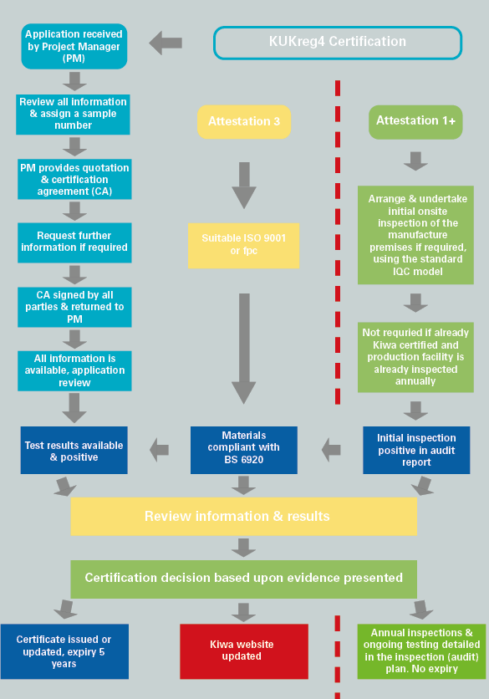

Requirements and test methods

General
This chapter details the requirements that products must be compliant with to be issued with KUKreg4 certification. These requirements will form part of the technical specification of the products and are detailed in the certificate.

Product requirements and test methods
The requirements the products shall satisfy, and the respective test methods and requirements are detailed in the following standards:

UK Regulators Specifications.
The exact specifications to be applied are detailed in the Kiwa test matrix (Calon) with further Individual test matrix being developed and agreed by certification as and when required. For assembled products, each generic component may require testing if the component is not already verified as being appropriate and complying with Reg 4 of the Water Supply (Water Fitting) Regulations.
or
Compliance to an appropriate standard BS/EN/BRL or other standard which demonstrates that the product does not waste, misuse undue consume, contaminate, or produce erroneous measurement of the water supply.
Acoustic testing and acoustic marking that may be detailed in standards are excluded unless otherwise requested by the applicant.
Deviations and interpretations from the text detailed in the standards can be made and will be documented by Kiwa Watertec.
For testing purposes, it may be necessary to cut/damage/destroy the test sample to achieve a result.

Materials in contact with water
The standards detailed above include a statement that all materials coming into contact with water intended for human consumption shall present no health risk or cause any change to the water in terms of quality, appearance, smell or taste.
Non-metallic materials in contact with water shall meet the requirements of BS 6920.
Note: Materials will be subject to re-assessment in contact with drinking water every five years.

Appropriate standards
The following is a list of standards that are considered as being appropriate by the Kiwa Expert Group. Additional testing using the Regulators Specifications may be required if the standard(s) do not consider other aspects of the Water Regulations, see doc 002-020 Equivalent standards and additional tests required for current standards.

Backflow Prevention Devices – Air gaps
BS EN 13076:2003 | Backflow prevention – Unrestricted Air gap – Family A – Type A
BS EN 13077: 2018 | Backflow prevention – Air gap with non-circular overflow (unrestricted) – Family A – Type B
BS EN 13077: 2023 | Backflow prevention – Air gap with non-circular overflow (unrestricted) – Family A – Type B
BS EN 13078: 2003 | Backflow prevention – Air gap with submerged feed & air inlet – Family A – Type C
BS EN 13079: 2003 | Backflow prevention – Air gap with injector - Family A – Type D
BS EN 14622: 2005 | Backflow prevention – Air gaps with circular overflow (restricted) – Family A – Type F
BS EN 14623: 2005 | Backflow prevention – Air gaps with minimum circular overflow – Family A – Type G
Devices – Mechanical
BS EN 12729: 2023 | Backflow prevention – RPZ valve – Family B Type A
BS EN 14367: 2005 | Backflow prevention – Non controllable preventer – Family C Type A
BS EN 14452: 2005 | Backflow prevention – Pipe interrupter with vent and moving element – Family D Type B
BS EN 14453: 2005 | Backflow prevention –Pipe interrupter with permanent vent – Family D Type C
BS EN 13959: 2004 | Backflow prevention – Check valves – Family E Type A, B, C and D
BS EN 14506: 2005 | Backflow prevention – Automatic Diverter – Family H Type C
Cylinders
BS EN 12897: 2016 | Indirectly heated unvented (closed) storage water heaters
Sanitary Taps
BS EN 200: 2008 | Single taps and combination taps, for water supply systems Type 1 and Type 2
BS EN 817: 2008 | Mechanical Mixing Valves PN 10
BS EN 816: 2017 | Automatic shut-off valves PN 10.
BS EN 1111: 2017 | Thermostatic mixing valves (PN10) – General Technical Specification.
BS EN 1287: 2017 | Thermostatic mixing valve Low pressure
DoH doc D 08 | Thermostatic mixing valves for healthcare premises
WC’s
BS EN 997: 2012 | WC Pans and WC Suites with integral Trap
BS EN 14055: 2016 | WC and urinal flushing cisterns
BS 1212-2: 1990 | Float valves — diaphragm type
BS 1212-3 1990 | Float valves — diaphragm type
BS 1212-4 1991 | Float valves — Compact type for WC flushing cisterns
BS 1212-4 2016 | Float valves — Compact type for WC flushing cisterns
Expansion Group
BS EN 1487:2000 | Building valves – Hydraulic safety groups – test requirements
BS EN 1488:2021 | Building valves – Expansion Groups – Test requirements
BS EN 1489:2000 | Building valves – Pressure Safety Valves
BS EN 1490:2000 | Building valves – Combined temperature and pressure relief valves
BS EN 1491:2000 | Building valves – Expansion valves
Pipes and fittings
BS 7291: part 1: 2010 | Thermoplastics pipe and fitting systems for hot and cold water for domestic purposes and heating installations in buildings. General requirements
BS 7291: part 2: 2010 | Specification for polybutylene (PB) pipe and associated fittings
BS 7291: part 3: 2010 | Specification for crosslinked polyethylene (PE-X) pipes and associated fittings
Currently accepted Kiwa NL Evaluation Guidelines.
Plastic piping systems
BRL K536 Part A | PVC- C (Type 1) hot and cold drinking water
BRL K536 Part B | PP-R intended for transport of hot and cold drinking water
BRL K536 Part C | PB intended for transport of hot and cold drinking water
BRL K536 Part D | PE-X intended for transport of hot and cold drinking water
BRL K536 Part E | PE-X (A) intended for transport of hot and cold drinking water
BRL K536 Part F | PP-R (A) intended for transport of hot and cold drinking water
BRL K536 Part G | PE-RT (A) intended for transport of hot and cold drinking water
BRL K536 Part H | PE-RT Type II intended for transport of hot and cold drinking water
Miscellaneous
BRL 612 | Water Meters up to 500mm, threaded only, Kiwa Cert must include EN 4064 pt2
BRL K622 | Flexible connecting hoses, utilises EN 13618: “Flexible hose assemblies in drinking water installations

Additional specifications/tests
See Kiwa Watertec doc 002-020 Equivalent standards and additional tests required for additional specifications/tests to be applied.

Materials in contact with water
The following additional requirements are always applicable:
All Materials - Requirements to avoid deterioration of the quality of the drinking water.
Products and materials, which (may) be in contact with water supplied for domestic or food production purposes. Does not apply to a water fitting supplying wholesome water where the use does not require to be wholesome when a suitable backflow prevention device is fitted.
Non-metallic materials in contact with water shall meet the requirements of BS 6920.
Note: Materials will be subject to re-assessment in contact with drinking water every five years, also see evaluation guideline EG005.

Opptional additional testing
Unified Water label performance criteria for water consumption. This criterion details the maximum flow, volume, or flush per litre of water with performance criteria being set and can be applied to sanitaryware including taps, showers, urinals, and baths. https://uwla.eu/technical-criteria/

Sampling

General
Test samples are required for testing that are representative of the product range requiring certification. Samples for test are expected to be from a production batch with pre-production or prototype samples not being accepted for final certification.
When the quote and certification agreement has been signed and returned the samples required for test will be detailed in the form SR1.
Note:
The samples required for test are usually based on the range of sizes with extremes and intermediate sizes being required for test or in the case of assemblies the most complex arrangement can be required for test.

Sampling requirments
As detailed in the Kiwa quality manual, deviation is allowed but this must be agreed with the Project Manager prior to sample selection being undertaken.

Re-test/failure
When additional samples need be selected due to a failure in testing, samples must be selected in accordance with the requirements detailed above. The applicant shall also provide information upon why the failure has occurred and give detail of the remedial action (if any) undertaken so that the failure is not repeated. Acceptance will be deemed appropriate by the certification manager.

Products which are already Kiwa certified products
Where a product is already certified by Kiwa ISO17065 certification scheme and the standard is considered appropriate (see 1.3 & 4.4) and additional tests/verifications have been undertaken (if any) then the product is deemed acceptable
(1+ only) If the above is satisfied, then there is no requirement to undertake a pre-audit/inspection of the manufacturer’s premises.
The IQC and inspection audit matrix (1+ only) will however need to be amended to include the UK specific requirements for additional testing if required and verification that the materials of construction are compliant with BS 6920.

Installation and Maintenance documents
There is no requirement for an installation and maintenance document, but Installation and maintenance documents may be required to confirm the products performance characteristics.

Marking

General
After receiving the KUKreg4 certificate the certified product(s) packaging or installation documents etc may be indelibly marked with the following Kiwa UK Logo (as appropriate).

When displaying the Kiwa pictogram, the guidelines detailed in the Kiwa use of pictograms available on the Kiwa.com
must be followed:
The product/packaging can be marked KUKreg4.

For further information please contact uk.marketing@Kiwa.com

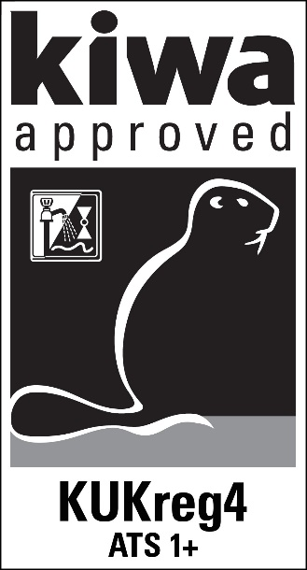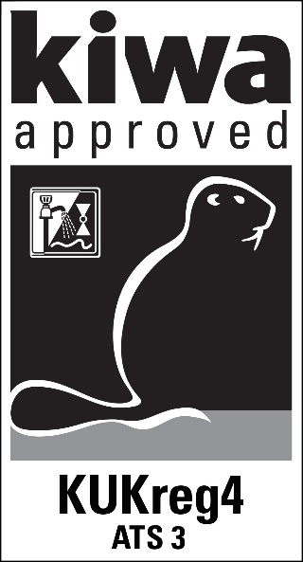

Requirements in respect of the quality system

General
This chapter contains the requirements which must be met by the supplier’s quality system.

For system level 1+ the manufacturer of the product(s) will be subject to an initial site audit/inspection of the manufacturing facilities to ensure that the manufacture of the product is suitable and that they have in place a suitable factory production control (fpc).
The test equipment is validated to ensure it is suitable to undertake fpc testing as part of the production process as detailed in the test/audit/inspection matrix, see clause 9.1.
The fpc testing undertaken as part of the production process must be agreed as being acceptable/appropriate and suitable by the certification manager prior to certification being issued.
After certification is issued Kiwa will annually inspect the manufacturing facilities to ensure on-going acceptance of the quality system and that the product(s) continues to satisfy the performance requirements detailed in this evaluation guideline. The details of on-going audit/inspection will be specified in the audit/inspection matrix that will be developed at the time of certification, see clause 9.

For system level 3 the manufacturer of the certified product(s) will be required to present evidence that they have in place a satisfactory factory production control fpc e.g., ISO 9001 or provide a confirmation that their quality system includes as a minimum, those controls detailed below.
If the applicant/certification holder is not the manufacturer, then the applicant must also have ISO 9001 accreditation at the time of the application or provide confirmation that their quality system includes as a minimum those controls detailed below.
The certification period is 5 years and will then require full re-type testing and verification.

Internal quality control/quality matrix
The internal quality control scheme (IQC scheme) which is applied and as a minimum, details and records the following *Manufacture only):

- what aspects are checked by the producer
- according to what methods such inspections are carried out
- how often these inspections are carried out
- in what way the inspection results are recorded and kept
- the presence, within the structure of the organization, of an officer in charge of the management of the quality system*
- Qualifications of the Quality Personnel and how is this defined*
- does the management provide evidence of its commitment to comply with their quality policy*
- Does the quality policy include a commitment to continuous improvement and contain a regular review of suitability*
- Is there a management representative which as appropriate communication within the organisation to ensure feedback of effectiveness of the quality system to the management*
- Who is responsible for the production facilities*
- does the management provide evidence of its commitment to comply with their quality policy*
- does the quality policy include a commitment to continuous improvement and contain a regular review of suitability*
- Control of test & measuring equipment:
- The supplier shall verify the availability of necessary test and measuring equipment for demonstrating product conformity with the requirements in this evaluation guideline.
- When required the equipment shall be kept calibrated (e.g., recalibration at interval)
- The status of actual calibration of each equipment shall be demonstrated by traceability through a unique ID.
- The supplier must keep records of the calibration results.
- The supplier shall review the validity of measuring data when it is established at calibration that the equipment is not suitable anymore.

This IQC scheme should at least be an equivalent derivative of the model IQC scheme included in Annex B. Considered to be acceptable if ISO 9001 accredited.

Procedures and working instructions
Shall be able to confirm that they manage the following:
- dealing with products showing deviations
- corrective actions to be taken if non-conformities are found.
- dealing with complaints about products and/or services delivered.
- should keep a record of all complaints about certified products*
- should take appropriate actions with respect to such complaints*
- should document the actions it has taken on account of complaints*
- training and competence of personnel*
Considered to be acceptable if ISO 9001 accredited.

Summary of tests and audit/inspections 1+

General
This chapter contains a summary of the following tests and audit/inspections to be carried out in the event of certification level 1+.
- Pre-certification tests: tests to ascertain that all the requirements recorded in the evaluation guideline are met.
- FPC testing: production tests carried out in the context of their own internal quality control system with regard to the production process and the end product.
- Inspection of the quality system of the manufacture: monitoring compliance of the IQC scheme and procedures.
- Confirmation that the non-metallic materials in contact with water are compliant with BS 6920 requirements.
- The production test equipment is validated to ensure it is suitable to undertake on-going production testing as detailed in the audit/inspection matrix.

The frequency with which Kiwa will carry out audit/inspection and or on-going testing is detailed in the test and audit/inspection matrix below.

Test & audit/inspection matrix Level 1+

Description of requirement | Clause  (This EG)
 |  | Pre-certification | Supervision by Kiwa after granting certification¹⁾
 |  |  | On-going Inspection²⁾ | frequency  (no./year)
Non-metallic materials compliant with BS 6920 and within its 5-year periodic cycle  Procedure/system in place to review that the non-metallic materials continue to have a valid approval (BS 6920).  Procedure/system in place to review that the mtls used in certified products have not changed. | 4 | Y | Y  Y  Y | 1  Y  Y
Mechanical requirements as detailed in the UK Regulators Specifications or appropriate standards | 4 | Y
Marking  Quality | 7  8 | Y  Y | Y  Y | 1  1
FPC testing as part of the production process.³⁾ | 4 | Y | On-going | On-going

¹⁾ In case of changes of the product or production process, compliance of the product to the performance requirements shall be determined
²⁾ The frequency of inspection visits is defined in chapter 10.6 of this evaluation guideline. During the inspection test the inspector checks the products on basis of a selection from the above-mentioned product requirements. For this purpose, at least one product/unit is selected from each product family, with a maximum of 1/3 of all certified products.
³⁾ The fpc production testing will be reviewed and agreed at the time of the initial audit and will be based upon the testing detailed in clause 4 but will relate to pressure tightness/porosity as far as is reasonably possible.

Agreements on the implementation of certification

General
Beside the requirements included in these evaluation guidelines, the general rules for certification detailed in the ‘Kiwa Regulations for Product Certification’ are also applicable.

These Regulations specify:
- The general rules for conducting the pre-certification tests, to be distinguished in:
  - the way suppliers are to be informed about an application is being handled,
  - how the tests are conducted,
  - the decision to be taken because of the pre-certification tests.
- The general directions for conducting inspections and the aspects to be audited (if any).
- The measurements to be taken by Kiwa in case of non-Conformities.
- Measures to be taken by Kiwa in case of improper Use of Certificates, Certification Marks, Pictograms and Logos.
- Terms for termination of the certificate.
- The possibility to lodge an appeal against decisions of measurements taken by Kiwa.
- Cancelation of certificates, see clause 10.15.
- Manufacturers who wish to cancel certificates must give 6 months’ notice of cancelation. If cancelation is within 6 months of date of renewal, then 50 % payment of the following year invoice in respect of Administrative Fees and Annual Certificate Fees
- After the cancellation has been notified, the manufacturer cannot mark their products with the relevant certification mark or claim compliance to the relevant certification mark
- Sleeping certificates.
c) Manufacturers can request a sleeping certificate if there is no production of Kiwa UK Certified products during the period of the certificate is sleeping
d) The first year the sleeping certificate is issued there is no charge, however every following year the manufacturer is subject to 50 % payment of next year’s invoice administrative fees and annual certificate fees

Certification staff
The staff involved in the certification may be sub-divided into:
- Project Managers: they oversee the evaluation process and co-ordinate inspections (if required) and pre-certification testing (if required).
- Product Manager: in charge of carrying out the pre-certification tests and assessing the inspectors’ reports.
- Site assessor/auditor: in charge of undertaking external inspections at the supplier’s works.
- Decision-makers: in charge of taking certification decisions after consulting the available information in connection with the pre-certification testing and inspections undertaken.

Report initial invetigation
The certification body shall access the results of the pre-certification tests in a report/file. This report/file shall comply with the following requirements:
- completeness: the reports verdicts about all requirements included in the evaluation guideline,
- traceability: the findings on which the verdicts have been based shall be in a recorded traceable manner,
- basis for decision: the decision maker shall be able to base the decision on the findings included within the report/file.

Decision for granting the certificate
The decision for granting the certificate shall be made by a qualified decision maker who has not been involved in the pre-certification tests/evaluation. The decision shall be recorded in a traceable manner (Calon).

Lay out of certification certificate
The product certificate shall conform to the model included as appendix A.

Nature and frequency of third party audits/inspections
The certification body for 1+ shall carry out inspections/audits of the manufacture/supplier at regular intervals to check whether the manufacture/supplier complies with their certification obligations. The frequency of inspection(s) is decided by the Board of Experts at the time this Evaluation Guideline took effect, the frequency was set at a one inspection (duration up to 2 days) visit per year. The duration of the inspection is dependent upon the requirements specified in clause 9.1 of this Evaluation Guideline and the number of products certified by Kiwa.

The audit program on site shall cover at least:
• the product requirements;
• the production process;
• the suppliers IQC scheme and the results obtained from inspections carried out by the supplier;
• the correct way of marking certified products;
• compliance with required procedures;
• handling complaints about products delivered.
Production testing and calibration of measuring equpment

The results of each inspection shall be recorded within a traceable report.

Interpretation of requirements
The Board of Experts may record the interpretation of requirements of these evaluation guidelines in one separate interpretation document.

Access for site audit/inspection (if required)
Kiwa shall be granted access to all facilities and production locations of the Company, except where precluded from doing so by restrictions included in agreements between the Company and Kiwa or by government regulations, and where KIWA has been notified in advance and is satisfied as to the validity of these restrictions. Refused or delayed access may result in withdrawal of Certification.

Co-operation with Kiwa
Audits and sampling of Products by Kiwa is for the benefit of the Company as well as in the public interest. While engaged in the performance of these duties, Kiwa shall be given every assistance necessary, and shall have the right to examine all records, equipment, areas, personnel and Company’s subcontractors; and investigation of complaints; bearing upon the duties and responsibilities of Kiwa or the Company with respect to compliance with Kiwa requirements.
While in a Company's facility, Kiwa representatives shall comply with all applicable health and safety rules and be accompanied by authorised Company personnel. The Company shall notify Kiwa in advance of any health and safety equipment necessary for access to the Company’s facility, or shall provide the necessary health and safety equipment for the Kiwa auditor’s use during the audit, along with instructions for proper use.
Kiwa auditors may discontinue an audit at a site where their health and safety may be at risk, if they are subject to sexual harassment or discrimination, or the conduct of the Company staff hampers the completion of a valid audit. The Company may, at any time for any reason, require that an auditor of Kiwa leave the facilities of the Company. An auditor shall immediately notify executive management of the Company and Kiwa if an audit is to be discontinued. If an audit is terminated its status is “attempted”.

Company records of complaints about its certified products
The Company shall retain a record of complaints and remedial actions taken by the Company, and shall make the record available to Kiwa upon request.
All complaints received by the Company, the subject of which is under the Company's control, and referring to Certified Products or services covered by the scope of the Certification provided by Kiwa, are included in this policy. At a minimum, the record shall include:
- The nature of the complaint
- Identification of the Product and/or services pertinent to the complaint
- Confirmation that remedial action(s) have been taken
- The status (open or closed) of the complaint, as known to the Company

All records and other information provided to Kiwa (upon request) shall remain the property of the Company and be handled by Kiwa as confidential information.

Modification and or addition to certified product(s)
A modification or addition to a certified product must be made using the Application Form A1. The exact details of the modification/addition must be clearly stated with supporting evidence provided and if necessary highlighted in a general assembly drawing.
The Certification Manager and if appropriate the Senior Managers will then determine the test requirements (if any) for the modified and/or additional product(s).
If appropriate, test reports from the Kiwa approved test laboratory will then be required prior to agreement for the modification.

Secondary certification
A secondary certification can be issued for products that already have a primary certification, this must be undertaken after permissions and clarifications have been received from the primary certification holder with supplementary information also being provided.
An application for a secondary certification must be made using the Application Form A2, this requires the following confirmations from the primary certification holder.
- Confirm that the products supplied to the secondary applicant are identical to the primary product(s)
- Confirm that the water pathways, materials, construction and method of manufacture is the same as that for the primary product(s).
- Give permission that the secondary applicant can use the existing Kiwa certification to progress this secondary certification. (the application form A2 requires reference to the existing approved product name and the corresponding secondary products designation (model no’s)
The Secondary applicant must provide details of the secondary product(s) designation/name and the following information must also be provided:
- installation and maintainance document and if appropriate product literature
- Confirmation of the secondary applicants ISO 9001 of fpc
- Revised identification to appear on the secondary product(s)
- Details of the identification that will be used on the secondary product(s) The identification must satisfy the appropriate performance standard.
The certification (evaluation) process (clause 3) is then followed, testing is not required if the product to be certified is exactly the same as that previously certified. The certification period will be the same as the primary certified product.

Fees
The following fees apply: -
- An application fee for the assessment of the materials and documents
- An initial and annual certification fee per scheme
- A fee for the initial and on-going (annual) audit/inspection assessment at the place of manufacture (if appropriate level 1+)
- Verification of fpc if ISO 9001 certificate is not available
- Hourly fee for additional work above that expected for an application
- Amendments to certifications and / or certification issues chargeable at the hourly rate

Complaints & appeals
Complaints and appeals regarding KUKreg4 should be addressed to the Kiwa Certification manager in the first instance. This will be reviewed by the senior management team and if appropriate to the Board of experts and impartiality committee for resolution.
In the event of there being irreconcilable differences the Kiwa Regulations for the Board of appeal shall be followed.

Certification withdrawn
Certification may be withdrawn for the following reasons: -
- Expiration of certification
- Failure of an audit/inspection, or not dealing with corrective actions (1+ only)
- change of materials or design (not notified)
- Failure to maintain ISO 9001 certification (as required)
- Reported product failure in service
- Licence holder’s request
- Breach of terms and conditions
- Non-payment of fees

Annex A: Model Certificate
Page 1 KUKreg4 Level 1+
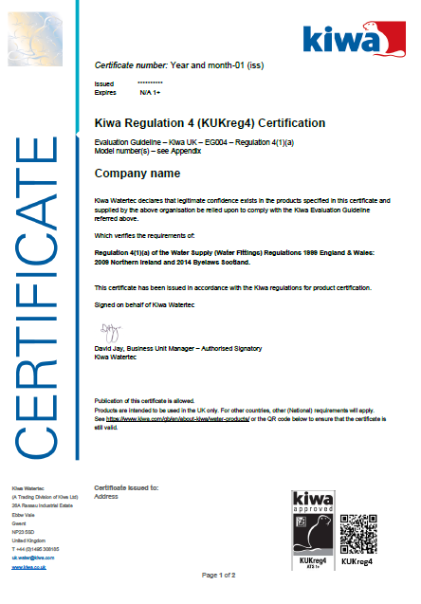

Page 1 KUKreg4 Level 3.
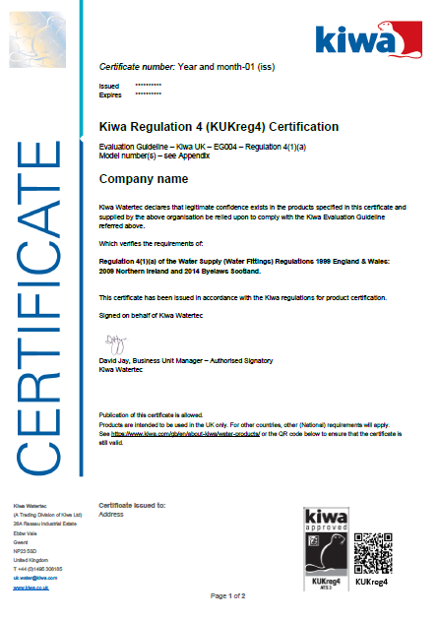

Page 2 KUKreg4.

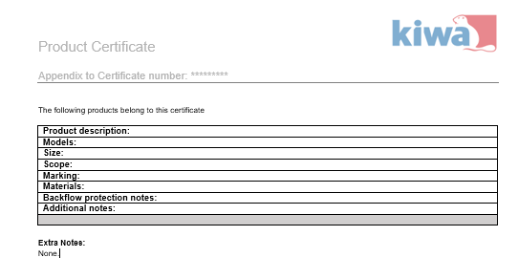

Annex B: Model IQC-scheme
Subjects | Aspects | Method | Frequency | Registration
Raw materials or materials supplied:
- Purchase specifications
- Incoming inspection raw materials
- Compliant with BS 6920 and still within the certification date i.e., 5 years.

Functional requirements (1+)
- Detailed in the UK Regulators specifications or the appropriate standard.

Production process, production equipment, material:
- procedures
- work instructions
- equipment
- release of product

Finished products

Measuring and testing equipment
- measuring equipment
- calibration
Validated 1+ only (Production testing)

Logistics
- internal transport
- storage
- preservation
- packaging
identification or marking of semi-finished and finished product(s)
- complaints received
- Deviations and corrective actions
- Working instructions
- Training/competence

