p
Evaluation Guideline
for the Kiwa Watertec certificate for
- Thermostatic Mixing Valves (Type 2 and Type 3)
- Attestation Level 1+ or 3
Kiwa Watertec - EG001
Issue No 7 – 21.05.2024
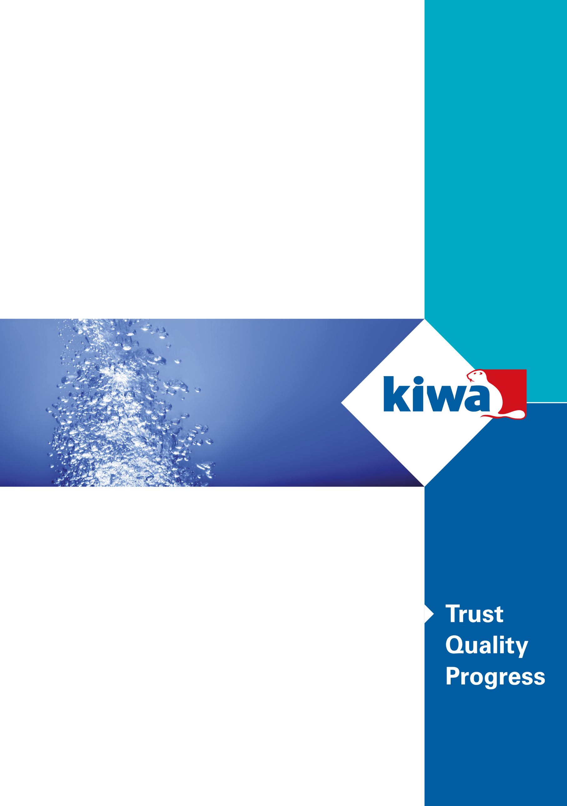

Preface
This evaluation guideline has been accepted by the Kiwa Watertec Expert Group, in which parties concerned in the Drinking Water sector in the UK are being represented. This Kiwa Watertec Expert Group also supervises the certification activities and where necessary requires this guideline to be revised.

This evaluation guideline will be used by Kiwa Watertec in conjunction with the Kiwa-Regulations for Product Certification. This regulation details the method employed by Kiwa for conducting the necessary investigations prior to issuing the product certificate and the method of external control.
The Kiwa-Regulations for Product Certification also refer to the “Kiwa Regulations for the Board of Appeal”. In reference to what has been mentioned in clause 2.1 of these regulations, the chairman and deputy chairman do not need to have a university degree in law.

This evaluation guideline is to be assessed by the Kiwa Watertec Expert Group at least every 5 years, but at the latest before May 2029.

1 Introduction 5
1.1 General 5
1.2 Field of application / scope 5
1.3 Acceptance of test report(s) provided by the supplier 6
1.4 The person undertaking the sampling 6
1.5 Acceptance of products that have an existing certification 6
1.6 Type 2 and Type 3 TMV certificate 6
2 Terms and definitions 7
3 Process for gaining Certification 8
3.1 Certification process 8
3.2 Pre & post certification evaluation & initial audit/inspection 8
3.3 Granting of the certificate 8
3.4 Additions and modifications to an existing certificate 8
4 Requirements and test methods 10
4.1 General 10
4.2 Product requirements and test methods 10
4.3 Materials in contact with water 10
4.4 Additional specifications: 10
4.5 Economy or water saving flowrates. 10
4.6 Optional additional testing 10
4.7 Audit testing 10
5 Sampling 11
5.1 General 11
5.2 Sampling requirments 11
5.3 Re-test/failure 11
5.4 Products which are already Kiwa certified products 11
5.5 The person undertaking the sampling 11
6 Installation and Maintenance documents 12
6.1 General 12
6.2 Type 2 TMV 12
6.3 Type 3 TMV 12
7 Marking 13
7.1 General 13
8 Requirements in respect of the quality system 14
8.1 General 14
8.2 Internal quality control/quality matrix 14
8.3 Procedures and working instructions 14
9 Summary of tests and audit/inspections 1+ 15
9.1 General 15
9.2 Test & audit/inspection matrix Level 1+ 15
10 Agreements on the implementation of certification 17
10.1 General 17
10.2 Certification staff 17
10.3 Report initial investigation 17
10.4 Decision for granting the certificate 17
10.5 Lay out of certification certificate 17
10.6 Nature and frequency third party audits/inspections 17
10.7 Interpretation of requirements 18
10.8 Access for site audit/inspection (if required) 18
10.9 Co-operation with Kiwa 18
10.10 Company records of complaints about its certified products 18
10.11 Modification and or addition to certified product(s) 18
10.12 Secondary certification 18
10.13 Fees 19
10.14 Complaints & appeals 19
10.15 Certification withdrawn 19
Annex A: Model Certificate 20
Annex B: Model IQC-scheme 25

Introduction

General
This evaluation guideline includes all relevant requirements which will be used by Kiwa Watertec as the basis for the issue and maintenance of an EN-ISO –IEC 17065 product certification that verifies compliance with the following standards:
EN 1111 (Type 2) Thermostatic mixing valves (high pressure) 2017.
EN 1287 (Type 2) Thermostatic mixing valves (low pressure). 2017.
Department of Health (DoH) HTM 04-01: Supplement. Performance specification D 08: thermostatic mixing valves (healthcare premises) 2017.

Kiwa are offering as an option an opportunity to test products against the Unified Water Label (UWL) performance criteria, the KUKreg4 certification can then be used to become a UWL marked product.

Type 2 and Type 3 TMV certification include alternatives for the level of surveillance required, these being:
Level 1+ requiring:
- initial type testing
- initial and annual audit/inspection of the manufacturing plant(s) factory production control (fpc)
- FPC testing as part of the production process
- initial and annual audit/inspection/review of the non-metallic materials in contact with water and compliance with BS 6920

The certification period being indefinite if all the schemes’ requirements are satisfied at the time of the annual inspection.
Level 3 requiring:
- initial type testing
- initial verification of factory production control (ISO 9001 or verification of FPC)
- initial review of the non-metallic materials in contact with water and compliance with BS 6920

The certification period is 5 years and will require re-type testing etc as detailed above.
Secondary certification holders will be required to have ISO 9001 or their FPC must be verified as being acceptable with their certification period being the same as the primary product.

Field of application / scope
Thermostatic mixing valves are intended for application in water installations with a static water pressure of maximum 10 bar and a maximum water temperature of 90°C. The recommended limits being 5 bar dynamic and 65°C, see table 1.

Thermostatic mixing valves are distinguished by their type:
- Type 2: thermostatic mixing valve for domestic use, referred in Part G of the UK Building Regulations clause 3.65. Scottish Building standards and Building Control Northern Ireland
- Type 3: thermostatic mixing valve for healthcare use, referred in Department of Health, Health Technical Memorandum (HTM) 04-01 Part A and B, England, Wales, and Northern Ireland and SHTM 04-01 NHS Scotland
Thermostatic mixing valves are designated by their pressure:
HP (High Pressure) or and LP (Low Pressure)
Thermostatic mixing valves are also designated by their use:
- Bath/Tub (T) or T44 or T46 for Type 3 (healthcare use)
- Shower (S)
- Washbasin (W)
- Bidet (B)
- Diverter (D) (healthcare use only)
The valves can then be designated for their intended use:
High pressure shower – HP-S
Low pressure bath shower mixer LP-T-S

The recommended limits for correct operation for TMV’s are indicated in table 1 below.

 | Type 2 TMV |  | Type 3 TMV
 | Low Pressure  BS EN 1287 | High Pressure  BS EN 1111 | Low Pressure  DoH Spec D 08 | High Pressure Doh Spec D 08
Flow Pressure,  Hot & Cold (Bar) | 0.1 to 1 | 0.5 to 5 | 0.2 to 1 | 1 to 5
Hot Supply Temperature (°C) | 55 to 65 | 55 to 65 | 55 to 65 | 55 to 65
Cold Supply Temperature (°C) | ≤ 25 | ≤ 25 | 5 to 20 | 5 to 20

Table 1 recommended limits for correct operation.

Acceptance of test report(s) provided by the supplier
When appropriate test reports from an EN-ISO/IEC 17025 accredited laboratory, a Kiwa product certificate or an approval certificate from an EN-ISO/IEC 17065 accredited certifier are supplied to demonstrate that the product meets the requirements of this evaluation guideline.

The laboratory shall be accredited to EN-ISO/IEC 17025 and include within their scope of accreditation the standards or specifications referred in this evaluation guideline.
The certifier shall be accredited to EN-ISO/IEC 17065 and include within their scope of accreditation the standards or specifications referred in this evaluation guideline.

These requirements are considered to have been fulfilled when a test report or certificate of accreditation can be shown, either issued by UKAS or one of the institutions with which UKAS has an agreement of mutual acceptance (ILAC).

Validity of tests reports/certification to be 5 years or as determined by the Kiwa Watertec Expert Group.
Kiwa Watertec will reserve the right to inspect the laboratory/certifier and require inter-laboratory trials and details of the laboratory procedures (in English) for testing and to carry out site-inspections, as necessary.

Sampling for test
The person who undertakes the sampling shall be totally independent of the manufacturing company. The independence of the person making the sample selection shall be verified by the signing of a declaration.
If the sampling is undertaken by an automatic process, then this is considered to be independent.
Note:
Transport of valves by air without adequate protection against damage e.g., by freezing or depressurisation, is not advised as the performance of the valve may be affected.

Acceptance of products that have an existing certification
Applicants who have an existing non Kiwa certification that requires a Type 2/3 certification, must complete, and return the form AA1 for each certification required. Kiwa will review and if appropriate issue certification.

Type 2 and Type 3 TMV certificate
The certificate to be issued by Kiwa Watertec is described as the Kiwa Watertec product certificate. A model of the certificate to be issued based on this Evaluation Guideline has been included in Annex A.
Certified products will be shown on the Kiwa Watertec website and will detail a brief description of the certified product(s) and details of the certification holder.
Certification will relate solely to the product(s) referred to in the Kiwa Watertec certificate. Statements by certification holders must refer only to the specifically certified product(s) as designated by the unique model reference.

Terms and definitions
For the products as referred to in this evaluation guideline the following terms and definitions are applicable:
Audit Testing: During the certification period, Type 3 valves must undergo limited performance testing to verify that the valve(s) continue to satisfy agreed performance criteria.
Board of Experts (expert group): A board set up by Kiwa Watertec, in which interested parties in the UK Drinking Water sector having a major interest in the development of policies and principles regarding the content and functioning of a certification system may participate and are represented”.
Certificate holder: the entity that enters the Kiwa UK certification agreement.
Evaluation Guideline: details the process and requirements for certification and is agreed by the Board of Experts.
Initial audit/inspection: initial audit of the manufacturing facility/site verifying their Internal quality control; (IQC). This is for attestation level 1+ only.
Inspection/audit matrix: details the initial and on-going expectations required to be undertaken to maintain certification.
IQC scheme: (Internal Quality Control): A description of the minimum expectations of the inspections required to be carried out by the supplier(manufacturer). For attestation Level 1+ only.
Pre-certification inspection: an assessment including fpc testing as part of production, materials are acceptable, and that the quality system is adequate to ascertain that all the requirements detailed in the Evaluation Guidelines are satisfied.
Primary certification: applicant who gains the initial certification of the product.
Product certificate: a document, in which Kiwa declares that a product may, on delivery, be deemed to comply with the product specification recorded in the product certificate.
Regulators Specifications’: series of test criteria applied to water products that can be used to determine that a water using product is compliant with the Water Supply (Water Fittings) Regulations/Byelaws.
Secondary certification (private label): applicant who does not manufacture product but uses already certified Type 2/3 product(s).
Supplier (manufacturer) the party that is responsible for ensuring that the product(s) meet and continues to meet the requirements on which the certification is issued.
Surveillance audit/Inspection: on-going audit of the manufacturing facility/site (level 1+ only) carried out after the certification has been issued. Verification that the FPC system and systems in place for the certified product(s) continues to satisfy the requirements recorded in the inspection plan within the certification cycle.
Thermostatic mixing valves: valve to compensate variations in pressure and/or temperature of the incoming water supplies and mixes hot and cold water and automatically controls the mixed water to a user-selected or pre-set temperature.
Third Party certification: applies for a primary certification who does not manufacture product and the manufacture does not have Type 2/3 certification.
Water Fittings Includes pipes, taps, ferrules, valves, cisterns, mixing valves and similar apparatus used in connection with the supply of water within a building.
Water Regulations are defined in the following:
UK Regulators Specifications | A set of test criteria issued by the UK Government for compliance with the UK Water Supply (Water Fittings) Regulations 1999.
UK Water Supply (Water Fittings) Regulations 1999. | UK Government Regulations protecting the supply of wholesome water supplied by the Water Undertaker
The Water Byelaws (Water Fittings) (Scotland) Byelaws 2014 | Scotland Government Regulations protecting the supply of wholesome water supplied by the Water Undertaker
The Water Supply (Water Fittings) Regulations (Northern Ireland) 2009 | Northern Ireland Government Regulations protecting the supply of wholesome water supplied by the Water Undertaker

Wholesome water. Water supplied by a water undertaker and complying with the requirements of regulations made under section 67 of the Water Industry act 1991. Wholesome water complies with the Drinking Water Directive and is intended for drinking, cooking, food preparation or other domestic purposes (also referred to as Potable Water or drinking water).

Process for gaining Certification

Certification process
- Applicants must complete and return the application form A3 or equivalent, or if supporting evidence is being provided from other test laboratories then form AA1 must be completed
- The application will be managed by a Project Manager (PM) who will either request further information or will process the application and documentation supplied. The installation documentation required will vary between Thermostatic valves, Type 2 and Type 3
- A sample number is assigned for each application made (Calon is used to manage the certification)
- A quote and certification agreement are produced that details the cost for certification and the generic product group to be certified. The certification agreement also refers to the activities related to obtaining and maintaining the Kiwa Watertec Certification for the product(s) detailed in the application document
- The certification agreement must be signed by the applicant and the manufacture of the product (if different) and if the product is not already certified by the manufacture
- The signed certification agreement and any information requested is returned to the PM
- Outstanding queries are resolved between the applicant and the PM and a final contract review of the application is undertaken including review of the non-metallic materials used, confirmation that the installation document details all the essential requirements of the scheme (see clause 6).
- Test samples are requested (SR1) or test reports are evaluated
- Samples received and inspected for appropriate identification EN 1111/1287/D 08) by the PM and then forwareded for testing
- For level 1+, the on-site audit/inspection of the manufacturing premises is arranged and undertaken, see
clause 8 & 9
- For level 3, the fpc is evaluated by either providing the applicants ISO 9001 certificate or details of their quality system, see clause 8
- If the evaluations are satisfactorily completed, then the certification file is collated with the following:
- Test results after evaluation
- Initial inspection of the manufacture/supplier (1+ only)
- ISO 9001 or fpc
- Non-Metallic materials are compliant with BS 6920
- Supporting evidence is available (installation documents/drawings, application FPC etc)
- Certification file is reviewed
- The certification decision is made as detailed in ISO/IEC 17065 (clause 7.6)
- The Kiwa website is updated (Calon is used to manage the website)
- The product certification certificate is produced and sent to the applicant (Calon)
- For 1+ certification the audit/inspection matrix is developed

Pre & post certification evaluation & initial audit/inspection
The pre & post certification evaluation and testing to be undertaken is based on the type i.e., TMV’s for domestic use or healthcare use:
- type testing (mechanical)
EN 1111 for High pressure TMV’s
EN 1287 for Low pressure TMV’s
DoH D 08 for TMV’s used in healthcare
- verification of the suitability of materials in contact with drinking water to determine whether the product(s) comply with the requirements of the scheme
- initial audit/inspection of the manufacturing facilities for 1+ Note: this is not required if already a Kiwa Certified Company and the production facility is already inspected annually
- Assessment of the fpc
- Installation documentation is provided that details minimum requirements

Granting of the certificate
After completing the post-certification evaluation, the results are collated and presented to the decision-maker for consideration. This person evaluates the results and decides whether the certificate can be granted or additional data and/or tests are necessary as stated in ISO 17065 (Clause 7.6.2).

Additions and modifications to an existing certificate
Additions and or modifications to an existing certificate will need to be fully documented and agreed prior to the modification(s) being agreed or the additions to be listed. The Type 2/3 scheme will need to be notified by the primary certification holder of the addition/modification by completing and returning the application form A3 along with supporting documentation. A decision will then be made by KUK certification upon how to progress to accommodate the addition and or modification, see 10.11.

Flow Chart for a new application, an application for a modified product or an additional product to range

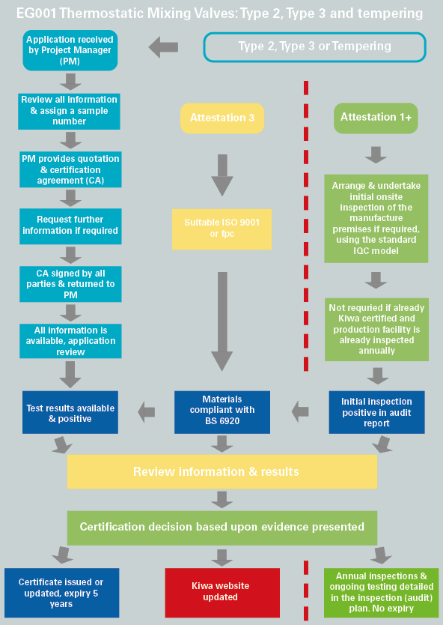

Requirements and test methods

General
This chapter details the requirements that thermostatic mixing valves must be compliant with to be issued with Type 2, Type 3 certification. These requirements will form part of the technical specification of the products and are detailed in the certificate.

Product requirements and test methods
The requirements the products shall satisfy, and the respective test methods and requirements are detailed in the following standards:
Domestic thermostatic mixing valves (Type 2)
BS EN 1111:2017 Sanitary tapware - Thermostatic mixing valves (PN 10) *.
And or
BS EN 1287:2017 Sanitary tapware - Low pressure thermostatic mixing valves**.
* Excluding: clause 6 (f), clause 7.1, b), clause 10 (UK certified products are required) and clause 17 (acoustic group is presumed to be unclassified)
**Excluding: clause 10.
Healthcare thermostatic mixing valves (Type 3)
Department of Health - Health Technical Memorandum 04-01: Supplement Performance specification D 08: thermostatic mixing valves (healthcare premises) 2017.

Deviations and interpretations from the text detailed in the standards can be made and will be documented by Kiwa Watertec.
For testing purposes, it may be necessary to cut/damage/destroy the test sample to achieve a result.

Materials in contact with water
The standards detailed above include a statement that all materials coming into contact with water intended for human consumption shall present no health risk or cause any change to the water in terms of quality, appearance, smell or taste.
Non-metallic materials in contact with water shall meet the requirements of BS 6920.
Note: Materials will be subject to re-assessment in contact with drinking water every five years, also see evaluation guideline EG004 and EG005.

Additional specifications:
The following additional requirements may be applicable:

Economy or water saving flowrates.
The TMV standards specify the flowrate requirements for the valves intended use.
If the valves do not satisfy the normal flowrate requirements, then there is an option for the valve to be classed as water saving or be classified as an economy valve (excluding bath/tub use). This economy classification must be detailed in the valve’s designations, see the information required in clause 6
- Type 2 TMV (excluding bath/tub use and only applicable to HP valves) for the water saving designation the mixed water flow rate is between 4.8 and 12 litre/minute
- Type 3 TMV, (excluding bath/tub use) for the economy designation the mixed water flow rate is less than 8 litre/minute

Optional additional testing
Unified Water label performance criteria for water consumption. This criterion details the maximum flow, volume, or flush per litre of water with performance criteria being set and can be applied to sanitaryware including taps, showers, urinals, and baths. https://uwla.eu/technical-criteria/

Audit testing
Type 3 thermostatic mixing valves must be performance audit tested (at the designation having the highest pressure and at the lowest designated flowrate) twice within the 5-year certification cycle and is only applicable to primary approved products.
For 1+ certification this may be managed by the requirements detailed in the IQC scheme.
In addition, the Installation and maintenance document and the valves identification will be verified as still being compliant.
Type 3 audit tests: Clauses 7.7, 7.9, 7.10 & 7.12 and 7.5 when appropriate.

Sampling

General
Test samples are required that are representative of the product range requiring certification. Samples for test are expected to be from a production batch with pre-production or prototype samples not being accepted for final certification.
When the quote and certification agreement has been signed and returned the samples required for test will be detailed in the form SR1.

Sampling requirments
For Type 3 valves, D 08 specifies the sample requirements (clause 4 of the standard).
For Type 2 valves, EN 1111 and EN 1287 specifies the sample requirements (clause 11 of the standard).

Re-test/failure
When additional samples need be selected due to a failure in testing, samples must be selected in accordance with the requirements detailed above. The applicant shall also provide information upon why the failure has occurred and give detail of the remedial action (if any) undertaken so that the failure is not repeated. This shall be determined by the certification manager.
For Type 3 valves D 08 specifies the testing of further samples (Annex D of the standard).

Products which are already Kiwa certified products
Where a product is already certified by Kiwa ISO17065 certification scheme and the standard is considered appropriate (see 1.3 & 4.2) and additional tests/verifications have been undertaken (if any) then the product is deemed acceptable.
If the above is satisfied, then there is no requirement to undertake a pre-inspection of the manufacturer’s premises or independent sampling.
The IQC and inspection audit matrix (1+ only) will however need to be amended to include the UK specific requirements for additional audit testing (if required) and verification that the materials of construction are compliant with BS 6920.

The person undertaking the sampling
The person who undertakes the sampling shall be totally independent of the manufacturing company. The independence of the person making the sample selection shall verified by the signing of a declaration.
Note:
Transport of valves by air without adequate protection against damage e.g., by freezing or depressurisation, is not advised as the performance of the valve may be affected.

Installation and Maintenance documents

General
An Installation and Maintenance (I&M) document in the English language shall be made available with the valves or a link provided to where the information can be found. This document shall include specific information upon the operating characteristics of the valve, maximum allowable temperatures and operational procedures and include the following:

Type 2 TMV

Model number/product code must be detailed

Operating conditions of use, pressure and temperature (hot & cold) table 1 in BS EN 1111 and BS EN 1287

Statement that valves operating outside these conditions of use cannot be guaranteed to operate as Type 2 valves

It’s designation of use:

LP (Low pressure to BS EN 1287) or HP (high pressure to BS EN 1111) or HP and LP if tested against both. Suffix B for bidet, S for shower, W for washbasin T for tub e.g., HP-S-T and LP-S-T. For valves that have an economy/water saving rating then suffix with ‘E’ e.g., HP-SE and LP-SE

Valves approved for designation of use HP only must state – if water supply is fed from a storage cistern by gravity, then the supply pressure should be verified to ensure the conditions of use are appropriate for the valve

Detail the recommended maximum set mixed water temperatures for applications of use

Include statement the recommended safe water temperature for children

Information upon the installation of the valve, this will include:
- Requirements for the valve accessibility to commission and maintain the valve
- If isolation valves are not provided, then a statement is required that states “The fitting of isolation valves is required and identify the preferred location
- If strainers are not provided, then a statement is required that states “The fitting of strainers is recommended and identify the preferred location

Information upon commissioning and testing of the valve, this will include:
- Method of adjusted the mixed water temperature
- Method for commissioning the valve
- Statement that mixed water temperature at the terminal fitting should never exceed 46ºC
- Information on residual flow during cold water supply isolation test
- Frequency of on-site testing (every 12 months)

Reference to be made to the installation shall comply with the Water Supply (Water Fittings) Regulations 1999

Type 3 TMV

Model number/product code must be detailed

Operating conditions of use, pressure and temperature (hot and cold), table 1 in D 08

Statement that valves operating outside these conditions of use cannot be guaranteed to operate as Type 3 valves

It’s designation of use:

LP (Low pressure) or HP (high pressure) suffix B for bidet, S for shower, W for washbasin T44 for tub fill at 44C or T46 for tub fill at 46C, D for diverter. e.g., HP-T44 and LP-T44. For valves that have an economy rating then suffix with ‘E’ e.g., HP-SE and LP-SE

Valves approved for designation of use HP only must state – if water supply is fed from a storage cistern by gravity, then the supply pressure should be verified to ensure the conditions of use are appropriate for the valve

Detail the recommended maximum set mixed water temperatures for applications of use

Information upon the installation of the valve, this will include:
- Requirements for the valve accessibility to commission and maintain the valve
- If isolation valves are not provided, then a statement is required that states “The fitting of isolation valves is required and identify the preferred location
- If strainers are not provided, then a statement is required that states “The fitting of strainers is recommended and identify the preferred location
h) Information upon commissioning and testing of the valve, this will include:
- Method of adjusted the mixed water temperature
- Method for commissioning the valve
- Statement that mixed water temperature at the terminal fitting should never exceed 46ºC
- Method and frequency (see appendix F of D 08 as a minimum frequency) for performing the in-service tests
i) Reference to be made to the installation shall comply with the Water Supply (Water Fittings) Regulations 1999.

Marking

General
After receiving the Kiwa certificate, the certified product(s) packaging or installation documents etc may be indelibly marked with the following Kiwa UK Logo(s) as appropriate.

When displaying the Kiwa pictogram, the guidelines detailed in the Kiwa use of pictograms available on the Kiwa.com
must be followed:
The product/packaging can be marked KUK Type 2, Type 3.

For further information please contact uk.marketing@Kiwa.com

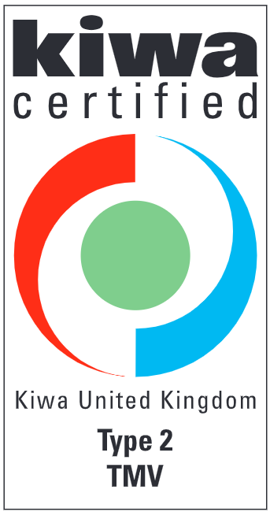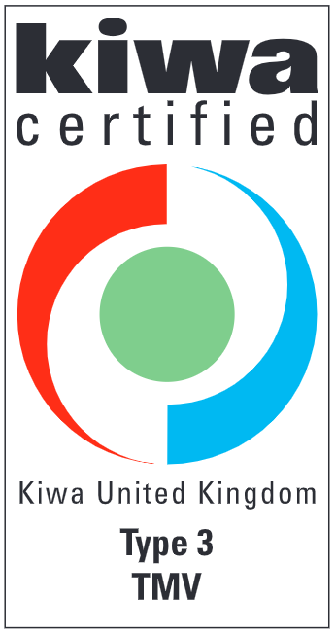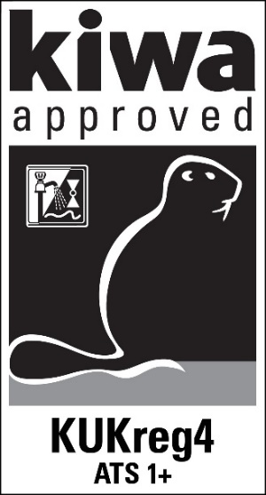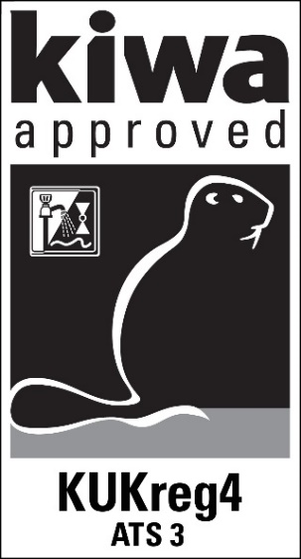

Requirements in respect of the quality system

General
This chapter contains the requirements which must be met by the supplier’s quality system.

For system level 1+ the manufacturer of the product(s) will be subject to an initial site inspection of the manufacturing facilities to ensure that the manufacture of the product is suitable and that they have in place a suitable factory production control (fpc).
The fpc testing undertaken as part of the production process must be agreed as being acceptable/appropriate and suitable by the certification manager prior to certification being issued.

After certification is issued Kiwa will annually inspect the manufacturing facilities to ensure on-going acceptance of the quality system and that the product(s) continues to satisfy the performance requirements detailed in this evaluation guideline.
The details of on-going inspection will be specified in the audit/inspection matrix that will be developed at the time of certification, see clause 9.

For system level 3 the manufacturer of the certified product(s) will be required to present evidence that they have in place a satisfactory factory production control (FPC) e.g., ISO 9001 or provide a confirmation that their quality system includes as a minimum, those controls detailed below.

If the applicant/certification holder is not the manufacturer, then the applicant must also have ISO 9001 accreditation at the time of the application or provide confirmation that their quality system includes as a minimum those controls detailed below.
The certification period is 5 years and will then require full re-type testing and verification.

Internal quality control/quality matrix
The internal quality control scheme (IQC scheme) which is applied & as a minimum details & records the following (*Manufacture only):
- what aspects are checked by the producer
- according to what methods such inspections are carried out
- how often these inspections are carried out
- in what way the inspection results are recorded and kept
- the presence, within the structure of the organization, of an officer in charge of the management of the quality system*
- Qualifications of the Quality Personnel and how is this defined*
- does the management provide evidence of its commitment to comply with their quality policy*
- Does the quality policy include a commitment to continuous improvement and contain a regular review of suitability*
- Is there a management representative which as appropriate communication within the organisation to ensure feedback of effectiveness of the quality system to the management*
- Who is responsible for the production facilities*
- does the management provide evidence of its commitment to comply with their quality policy*
- does the quality policy include a commitment to continuous improvement and contain a regular review of suitability*
- Control of test & measuring equipment:
- The supplier shall verify the availability of necessary test and measuring equipment for demonstrating product conformity with the requirements in this evaluation guideline.
- When required the equipment shall be kept calibrated (e.g. recalibration at interval).
- The status of actual calibration of each equipment shall be demonstrated by traceability through a unique ID.
- The supplier must keep records of the calibration results.
- The supplier shall review the validity of measuring data when it is established at calibration that the equipment is not suitable anymore.
This IQC scheme should at least be an equivalent derivative of the model IQC scheme included in the annex B. Considered to be acceptable if ISO 9001 accredited.

Procedures and working instructions
Shall be able to confirm that they manage the following:
- dealing with products showing deviations
- corrective actions to be taken if non-conformities are found
- dealing with complaints about products and/or services delivered
- should keep a record of all complaints about certified products*
- should take appropriate actions with respect to such complaints*
- should document the actions it has taken on account of complaints*
- training and competence of personnel*
- Storage temperature (TMV’s only)
Considered to be acceptable if ISO 9001 accredited

Summary of tests and audit/inspections 1+

General
This chapter contains a summary of the following tests and audit inspections to be carried out in the event of certification, level 1+.
- Pre-certification tests to ascertain that all the requirements recorded in the evaluation guideline are met.
- FPC testing: production tests carried out in the context of their own internal quality control system with regard to the production process and the end product.
- Inspection of the quality system of the manufacture: monitoring compliance of the IQC scheme and procedures.
- Confirmation that the non-metallic materials in contact with water are compliant with BS 6920 requirements.
- The production test equipment is validated to ensure it is suitable to undertake on-going testing as detailed in the audit/inspection matrix.
The frequency with which Kiwa will carry out inspection and or on-going testing is detailed in the test and audit/inspection matrix below.

Test & audit/inspection matrix Level 1+

Description of requirement | Clause in standard
 |  | Pre-certification | Supervision by Kiwa after granting of certificate¹⁾
 |  |  | Inspection³⁾ | frequency²⁾  (no./year)
Type 2: TMV (BS EN 1111 & or BS EN1287)
Materials  Non-metallic materials compliant with BS 6920 and within 5-year certification period. this EG  Procedure/system in place to review that the non-metallic materials continue to have a valid approval (BS 6920).  Procedure/system in place to review that the mtls used in certified products have not changed. | 4.3 | Y | Y  Y  Y | 1  1  1
Mechanical requirements as detailed in the appropriate BS EN document. | 7-16 | Y
Marking, this EG  Marking  Quality, this EG  Installation doc, this EG | 7  7.1  8  6 | Y  Y  Y  Y | Y  Y  Y | 1  1  1
FPC testing as part of the production process.³⁾ | 4 | Y | On-going | On-going

¹⁾ In case of changes of the product or production process, compliance of the product to the performance requirements shall be determined
²⁾ The frequency of inspection visits is defined in chapter 10.6 of this evaluation guideline.
³⁾ The fpc production testing will be reviewed and agreed at the time of the initial audit and will be based upon the testing detailed in clause 4 but will relate to pressure tightness/porosity as far as is reasonably possible.

Description of requirement | Clause in standard
 |  | Pre-certification | Supervision by Kiwa after granting of certificate¹⁾
 |  |  | inspection³⁾ | frequency²⁾  (no./year)
Type 3 TMV (D O8)
Materials  Non-metallic materials compliant with BS 6920 and within 5-year certification period. this EG  Procedure/system in place to annually review that the non-metallic materials continue to have a valid approval (BS 6920).  Procedure/system in place to annually review that the mtls used in certified products have not changed. | 4.3 | Y | Y  Y  Y | 1  1  1
Functional requirements
- Water tightness | 5.0 | Y | Y | 1
- flow rate | 7.3 | Y | Y | 1 in 5
- Thermal performance tests, as applicable | 7.4 – 7.12 | Y | Y | 1 in 5
- Durability on/off etc  - Durability of thermostat  - Suite of audit tests, this EG | 6.1 -6.2  6.3  4.7 | Y | Y | 1 in 5  1 in 5  1 in 18 mths
Marking, this EG  Marking  Quality, this EG  Installation doc, this EG | 7  9  8  6 | Y  Y  Y  Y | Y  Y  Y  Y | 1  1  1  18 months
Marking, this EG  Marking  Quality, this EG  - Installation doc, this EG | 7  11  8  6 | Y  y  Y  Y | Y  y  Y  Y | 1  1  1  1 in 3

¹⁾ In case of changes of the product or production process, compliance of the product to the performance requirements shall be determined
²⁾The frequency of inspection visits is defined in chapter 10.6 of this evaluation guideline. During the inspection test the inspector checks the products on basis of a selection from the above-mentioned product requirements. For this purpose, at least one product/unit is selected from each product family, with a maximum of 1/3 of all certified products
³⁾ Inspections/testing as indicated are to be conducted either by
- the manufacturer in their own ISO 17025 accredited laboratory,
- an ISO 17025 accepted accredited laboratory.

Agreements on the implementation of certification

General
Beside the requirements included in these evaluation guidelines, the general rules for certification detailed in the ‘Kiwa Regulations for Product Certification’ are also applicable.

These Regulations specify:
- The general rules for conducting the pre-certification tests, to be distinguished in:
  - the way suppliers are to be informed about an application is being handled
  - how the tests are conducted
  - the decision to be taken because of the pre-certification tests
- The general directions for conducting inspections and the aspects to be audited (if any)
- The measurements to be taken by Kiwa in case of non-Conformities
- Measures to be taken by Kiwa in case of improper Use of Certificates, Certification Marks, Pictograms and Logos
- Terms for termination of the certificate
- The possibility to lodge an appeal against decisions of measurements taken by Kiwa
- Cancelation of certificates, see clause 10.15
- Manufacturers who wish to cancel certificates must give 6 months’ notice of cancelation. If cancelation is within 6 months of date of renewal, then 50 % payment of the following year invoice in respect of Administrative Fees and Annual Certificate Fees
- After the cancellation has been notified, the manufacturer cannot mark their products with the relevant certification mark or claim compliance to the relevant certification mark
- Sleeping certificates
c) Manufacturers can request a sleeping certificate if there is no production of Kiwa UK Certified products during the period of the certificate is sleeping
d) The first year the sleeping certificate is issued there is no charge, however every following year the manufacturer is subject to 50 % payment of next year’s invoice administrative fees and annual certificate fees

Certification staff
The staff involved in the certification may be sub-divided into:
- Project Managers: they oversee the evaluation process and co-ordinate inspections (if required) and pre-certification testing (if required)
- Product Manager: in charge of carrying out the pre-certification tests and assessing the inspectors’ reports.
- Site assessor/auditor: in charge of undertaking external inspections at the supplier’s works.
- Decision-makers: in charge of taking certification decisions after consulting the available information in connection with the pre-certification testing and inspections undertaken.

Report initial investigation
The certification body shall access the results/findings of the pre-certification tests in a report/file. This report/file shall comply with the following requirements:
- completeness: the reports verdicts about all requirements included in the evaluation guideline
- traceability: the findings on which the verdicts have been based shall be in a recorded traceable manner
- basis for decision: the decision maker shall be able to base the decision on the findings included within the report/file.

Decision for granting the certificate
The decision for granting the certificate shall be made by a qualified decision maker who has not been involved in the pre-certification tests/evaluation. The decision shall be recorded in a traceable manner (Calon).

Lay out of certification certificate
The product certificate shall conform to the model included as appendix A.

Nature and frequency third party audits/inspections
The certification body for 1+ shall carry out audits/inspections of the manufacture/supplier at regular intervals to check whether the manufacture/supplier complies with their certification obligations. The frequency of inspection(s) is decided by the Board of Experts at the time this Evaluation Guideline took effect, the frequency was set at a one inspection (duration up to 2 days) visit per year. The duration of the inspection is dependent upon the requirements specified in clause 9.1 of this Evaluation Guideline and the number of products certified by Kiwa.

The audit program on site shall cover at least:
• the product requirements;
• the production process;
• the suppliers IQC scheme and the results obtained from inspections carried out by the supplier;
• the correct way of marking certified products;
• compliance with required procedures;
• handling complaints about products delivered.
- Production testing and calibration of measuring equipment
The results of each inspection shall be recorded within a traceable report.

Interpretation of requirements
The Board of Experts may record the interpretation of requirements of these evaluation guidelines in one separate interpretation document.

Access for site audit/inspection (if required)
Kiwa shall be granted access to all facilities and production locations of the Company, except where precluded from doing so by restrictions included in agreements between the Company and Kiwa or by government regulations, and where Kiwa has been notified in advance and is satisfied as to the validity of these restrictions. Refused or delayed access may result in withdrawal of Certification.

Co-operation with Kiwa
Audits and sampling of Products by Kiwa is for the benefit of the Company as well as in the public interest. While engaged in the performance of these duties, Kiwa shall be given every assistance necessary, and shall have the right to examine all records, equipment, areas, personnel and Company’s subcontractors; and investigation of complaints; bearing upon the duties and responsibilities of Kiwa or the Company with respect to compliance with Kiwa requirements.
While in a Company's facility, Kiwa representatives shall comply with all applicable health and safety rules and be accompanied by authorised Company personnel. The Company shall notify KIWA in advance of any health and safety equipment necessary for access to the Company’s facility, or shall provide the necessary health and safety equipment for the Kiwa auditor’s use during the audit, along with instructions for proper use.
Kiwa auditors may discontinue an audit at a site where their health and safety may be at risk, if they are subject to sexual harassment or discrimination, or the conduct of the Company staff hampers the completion of a valid audit. The Company may, at any time for any reason, require that an auditor of Kiwa leave the facilities of the Company. An auditor shall immediately notify executive management of the Company and Kiwa if an audit is to be discontinued. If an audit is terminated its status is “attempted”.

Company records of complaints about its certified products
The Company shall retain a record of complaints and remedial actions taken by the Company, and shall make the record available to Kiwa upon request.
All complaints received by the Company, the subject of which is under the Company's control, and referring to Certified Products or services covered by the scope of the Certification provided by Kiwa, are included in this policy. At a minimum, the record shall include:
- The nature of the complaint
- Identification of the Product and/or services pertinent to the complaint
- Confirmation that remedial action(s) have been taken
- The status (open or closed) of the complaint, as known to the Company

All records and other information provided to Kiwa (upon request) shall remain the property of the Company and be handled by Kiwa as confidential information.

Modification and or addition to certified product(s)
A modification or addition to a certified product must be made using the Application Form A3. The exact details of the modification/addition must be clearly stated with supporting evidence provided and if necessary highlighted in a general assembly drawing.
The Certification Manager and if appropriate the Senior Managers will then determine the test requirements (if any) for the modified and/or additional product(s).
If appropriate, test reports from the Kiwa approved test laboratory will then be required prior to agreement for the modification.

Secondary certification
A secondary certification can be issued for products that already have a primary certification, this must be undertaken after permissions and clarifications have been received from the primary certification holder with supplementary information also being provided.
An application for a secondary certification must be made using the Application Form A2, this requires the following confirmations from the primary certification holder.

- Confirm that the products supplied to the secondary applicant are identical to the primary product(s)
- Confirm that the water pathways, materials, construction and method of manufacture is the same as that for the primary product(s)
- Give permission that the secondary applicant can use the existing Kiwa certification to progress this secondary certification. (the application form A2 requires reference to the existing approved product name and the corresponding secondary products designation (model no’s)
The Secondary applicant must provide details of the secondary product(s) designation/name and the following information must also be provided:
- installation and maintainance document and if appropriate product literature
- Confirmation of the secondary applicants ISO 9001 of FPC
- Revised identification to appear on the secondary product(s)
- Details of the identification that will be used on the secondary product(s) The identification must satisfy the appropriate performance standard
The certification (evaluation) process (clause 3) is then followed, testing is not required if the product to be certified is exactly the same as that previously certified. The certification period will be the same as the primary certified product.

Fees
The following fees apply: -
- An application fee for the assessment of the materials and documents
- An initial and annual certification fee per scheme
- A fee for the initial and on-going (annual) audit/inspection assessment at the place of manufacture (if appropriate level 1+)
- Verification of FPC if ISO 9001 certificate is not available
- Hourly fee for additional work above that expected for an application
- Amendments to certifications and / or certification issues chargeable at the hourly rate

Complaints & appeals
Complaints and appeals regarding Type2/3 certification should be addressed to the Kiwa Certification manager in the first instance. This will be reviewed by the senior management team and if appropriate to the Board of experts and impartiality committee for resolution.
In the event of there being irreconcilable differences the Kiwa Regulations for the Board of appeal shall be followed.

Certification withdrawn
Certification may be withdrawn for the following reasons: -
- Expiration of certification
- Failure of an audit/inspection, or not dealing with corrective actions (1+ only)
- Change of materials or design (not notified)
- Failure of a test audit (D 08 only)
- Failure to maintain ISO 9001 certification (as required)
- Reported product failure in service
- Licence holder’s request
- Breach of terms and conditions
- Non-payment of fees

Annex A: Model Certificate
Page 1, Type 2 Level 1+

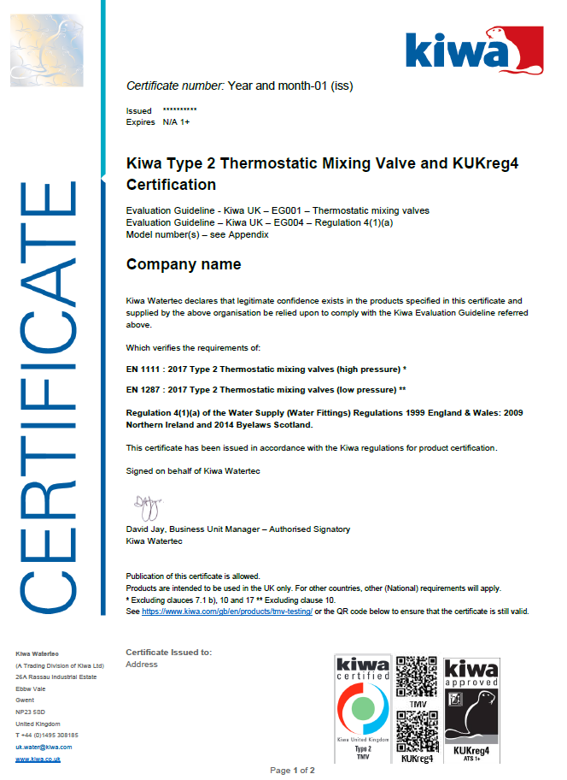
Page 1, Type 2 Level 3

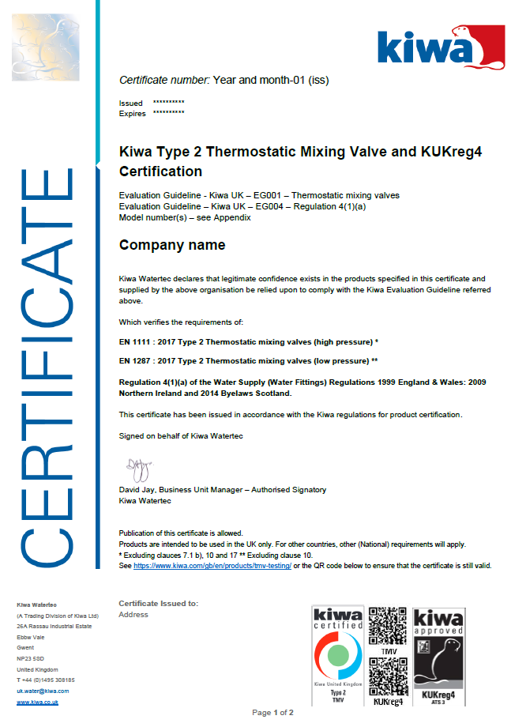

Page 1, Type 3 Level 1+

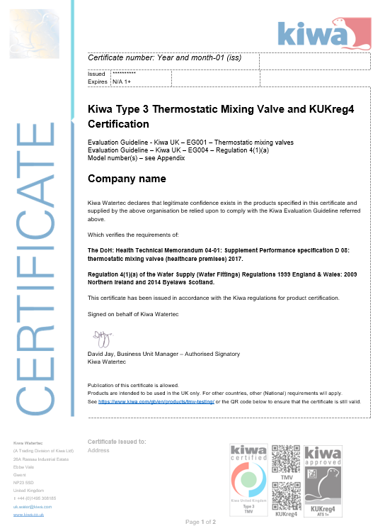

Page 1, Type 3 Level 3

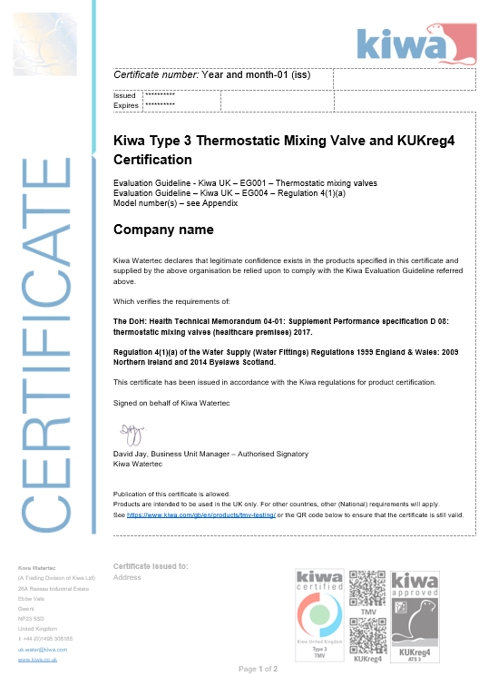

Page 2, Type 2 and 3 valves

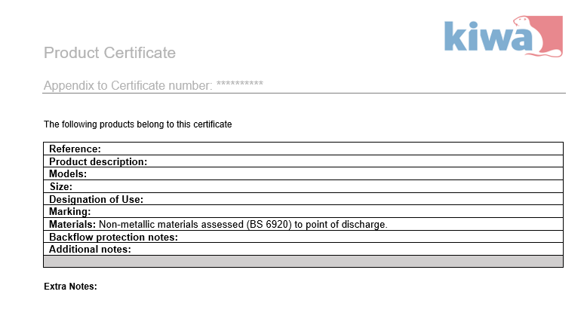

Annex B: Model IQC-scheme
Subjects | Aspects | Method | Frequency | Registration
Raw materials or materials supplied:
- Purchase specifications
- Incoming inspection raw materials
- Compliant with BS 6920 and still within the certification date i.e., 5 years

Functional requirements (1+)
- Detailed in the appropriate performance standard
- Suite of audit tests as appropriate
- Marking
- Installation documents

Production process, production equipment, material:
- procedures
- work instructions
- equipment
- release of product

Finished products

Measuring and testing equipment
- measuring equipment
- calibration
- Validated 1+ only

Logistics
- internal transport
- storage/stock rotation
- preservation
- packaging
- identification or marking of semi-finished and finished products
- Complaints received
- Deviations and corrective actions
- Working instructions
- Training/competence

